**[1]** [**https://www.nxp.com/products/wireless-connectivity/proprietary-ieee-802.15.4-based/bluetooth-smart-bluetooth-low-energy:BLUETOOTH-LOW-ENERGY-NXP**](https://www.nxp.com/products/wireless-connectivity/proprietary-ieee-802.15.4-based/bluetooth-smart-bluetooth-low-energy:BLUETOOTH-LOW-ENERGY-NXP)

**Bluetooth Smart / Bluetooth Low Energy (BLE)**

Bluetooth® Low Energy (BLE) is a key technology within the IoT. It connects BLE-enabled products to smart mobile devices. The connectivity options and extreme low power make BLE the wireless technology of choice for the development of advanced, long-lasting wearable computing products.

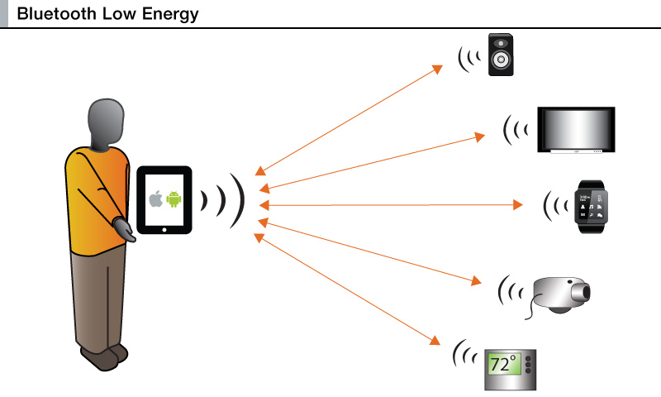

**[2]** [**https://www.bluetooth.com/bluetooth-technology/topology-options/broadcast**](https://www.bluetooth.com/bluetooth-technology/topology-options/broadcast)

Bluetooth® Low Energy (LE) enables short-burst wireless connections and uses multiple network topologies, including a broadcast topology for one-to-many (1:m) device communications.

**[3]** [**https://mobidev.biz/blog/bluetooth-low-energy-for-your-next-internet-of-things-project**](https://mobidev.biz/blog/bluetooth-low-energy-for-your-next-internet-of-things-project)

Bluetooth Low Energy is one of such unifying standards that have already settled down in the IoT world. As opposed to the classic Bluetooth, it offers considerably reduced power consumption with a similar communication range, with an approximate theoretical maximum of 100 m (330 ft).

BLE technology offers a variety of possible application: from wearables and smart homes to healthcare, from connected cars to large-scale enterprise sensor networks and industrial IoT.

The keys to this technology are simplicity, compatibility with numerous devices, and low cost in both development and support. There are 3 types of connection that could be implemented in next Internet of Things project.

**One-to-One** is widely used in the health & fitness domain, where low power consumption devices like fitness trackers and smart watches are used to track daily activities and send this data to users' smartphones. Healthcare benefits from it, too: numerous medical devices can be connected via BLE software. Below you will find a fitting example of Bluetooth Low Energy in automotive IoT.

**One-to-Many**is applied in the areas involving**item-tracking and way-finding beacons**, as well as**point-of-interest beacons**. Smartphones have become the ultimate devices for the said purposes, where sending small bits of data using little energy is enough to perform the required action.

**Many-to-Many** presuppose **home automation** and **sensor networks** as the most promising areas of use, well-suited for developers and system integrators in the IoT sphere. The most recent [Bluetooth 5](https://mobidev.biz/redirect/https:/www.bluetooth.com/specifications/bluetooth-core-specification/bluetooth5)—with a promised 4x range, 2x speed and 8x broadcasting message capacity—will cover the needs of smart homes and offices, allowing to connect various devices throughout entire building.

[4] <https://globenewswire.com/news-release/2017/11/21/1197922/0/en/Bluetooth-Low-Energy-IoT-Market-Report-2017-BLE-s-Biggest-Competition-Comes-from-802-15-4-and-the-Thread-Zigbee-Ecosystem.html>

Ongoing improvements with Bluetooth Low Energy (BLE) combined with low cost chips and a large and growing developer community have made BLE a leading Internet of Things (IoT) technology. Billions of BLE enabled smartphones has created a massively scaled ecosystem for IoT developers. BLE is driving markets such as health and fitness wearable sensors where low power and 1 MB/s throughput is required. The expanded network range, throughput and capacity with Bluetooth 5 as well as the completion of the Bluetooth mesh specification has also made BLE a disruptor for fixed sensor networks.

BLE's biggest competition comes from 802.15.4 and the Thread/Zigbee ecosystem with a decade of development on IoT wireless sensor networking. Combo chips are a growing trend and BLE/802.15.4 chips provide a future-proofing solution. Multi-protocol chips and modules with BLE have become the sensor interface for the next generation of wireless sensor networks (WSN) where smart devices provide the app and GUI. BLE as an add-on is emerging for asset tracking, remote monitoring and workflow optimization in manufacturing, healthcare, food services, hospitality and other enterprises.

Between 2016 and 2022, annual shipments of BLE chipsets for IoT markets will increase by 524%. Wireless sensor network BLE markets such as industrial sensors, smart homes and building automation will increase 3X faster than other BLE IoT markets over this period.

[5] <https://www.beaconzone.co.uk/blog/the-use-of-beacons-in-smart-cities/>

*Challenge for the attention of BLE technology is the limited range problem; the range is directly dependent on Broadcasting Signal Power. An increase in signal power makes BLE devices less energy-efficient. Moreover it is necessary to improve accuracy in determining proximity to a BLE device.*

The range problem will become less of an issue once [Bluetooth 5](https://www.beaconzone.co.uk/blog/category/bluetooth5/) devices become available.

Prepared by:

Asima Nisar – PhD CS candidate

52091 – Spring 2018